

WRITTEN BY

QWICKFUSION

FOR

PARKSTONE CAPITAL LIMITED

***CONTENTS***

1. Introduction
2. Login
3. Dashboard/Home
4. Modules/Pages

***INTRODUCTION***

The Parkstone Capital software is a new software designed and developed specifically for Parkstone Capital limited by Qwickfusion. Parkstone Capital is an investment company and as such, this software is intended to allow employees keep adequate records and control of all transactions pertaining to each investor and also, gives higher management the opportunity to oversee all transactions and also keep track of their own investments and transactions. This is to enhance the overall output of business transactions.

The Parkstone Capital software is a web application. All one needs to run it after installation is a web browser and a working WiFi connection.

Another significant advantage of the Parkstone Capital software is its automated creation and calculation of financial reports from all data entered. A regular business accountant has to spend extra hours balancing financial sheets doing other forms of book keeping. This software does this automatically. It removes errors by 99.9%, making financial projections, profit or loss calculations very accurate.

**IMPORTANT:** All options with * must be filled out to ensure smooth processing.

***LOGIN***

1. To enter/start Parkstone Capital, first make sure your computer is connected to the WiFi.
2. Open your web browser (Mozilla Firefox, Google Chrome, Internet Explorer, etc).
3. In the URL box, type <http://192.168.1.211> and press ‘Enter’.
4. This takes you to the default login page as seen below.

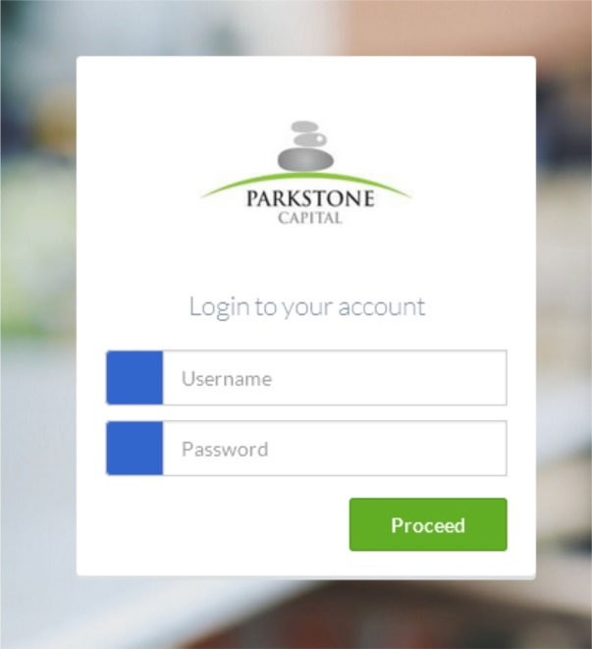

1. In the username box, type your username and subsequently your password in the password box.
2. Click on the ‘Proceed’ button. This takes you to the dashboard.

***DASHBOARD***

The dashboard is the home page. It is a menu page that will help users navigate to other pages.

1. Upon a successful login, you are presented with the dashboard.
2. The Parkstone software contains many pages that can be accessed on the left side of the page.
3. Other icons on the top right side of the page show the total number of unapproved investors, terminations, payments as well as a support/help button and the logout button.
4. The number of pending approvals, important dates and general stats are also displayed on the dashboard screen.
5. Below is an illustration of the dashboard page.

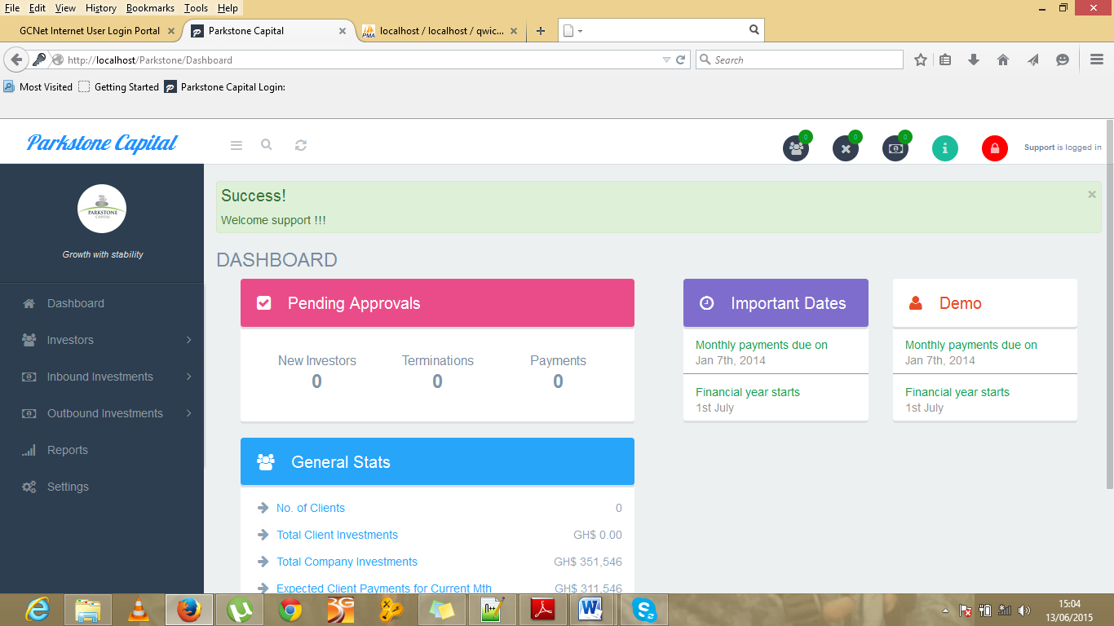

***MODULES/PAGES***

The main aspect and aim of the Parkstone Capital software is found in this section: the Modules/Pages. These are menu options that represent the core functionalities that make up the entire software program. Under this section we have:

1. Investors.
2. Inbound Investors.
3. Outbound Investors.
4. Reports.
5. Settings.

All of which have various other sub divisions.

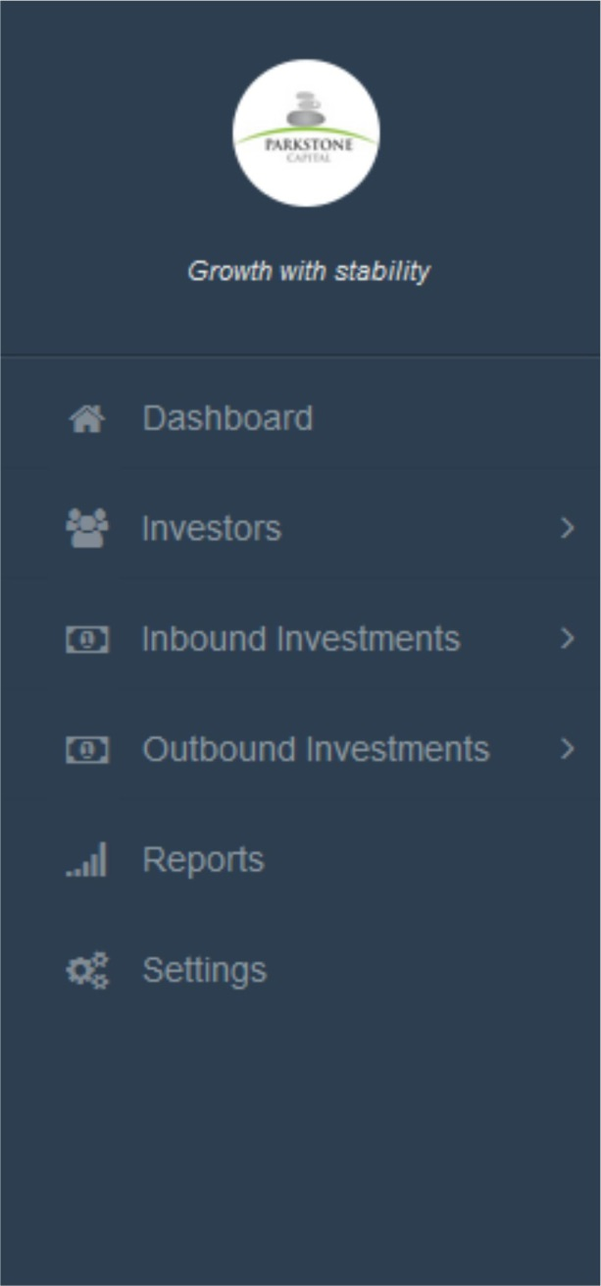

1. **Investors**

The investors section comes with three sub sections:

1. Add New Investors for adding new investors.
2. Approve Investors for senior staff members only.
3. List/Edit Investors that displays all investors registered to the company after approval.

Click on the Add New Investor icon and it takes you to a page where you choose what type of investor you are requesting to add. Select one and click the proceed button.

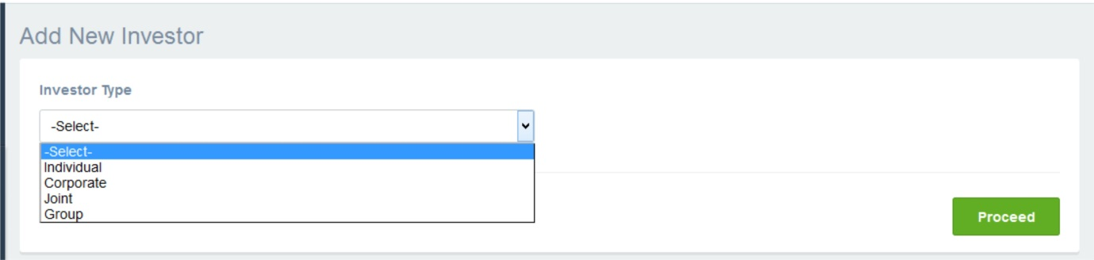

This in turn takes you to a screen that requests more details of our new applicant. Fill it and proceed.

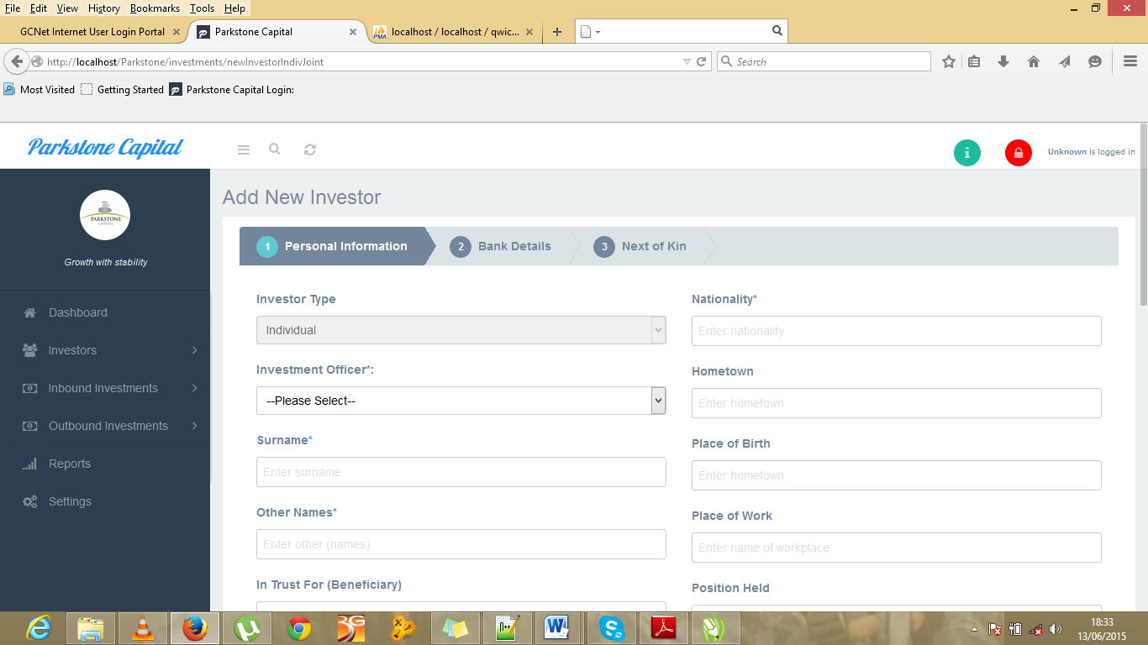

After completion of this stage, it is the duty of the super administrator to log in with their account in order to approve the new applicants before any investments can be made.

1. **Inbound Investments**

The inbound investments section also comes with seven options. This is where all activities involving the investor and his investments take place. The various sections are:

1. New Investment.
2. Manage Investment.
3. Daily Maturity List.
4. Monthly Maturity List.
5. Approve Terminations.
6. Approve Payments.
7. Make Payments.

After registering investors, the inbound investments section is where you come to make the investments. Individual, Corporate, Joint or Group investor type is selected. Then you proceed to fill the details of the investment and then Process it. The Process option allows for it to be scanned for approval, any errors or omissions will be detected here and you will be notified. Once the new investment form is properly filled, you click the submit button.

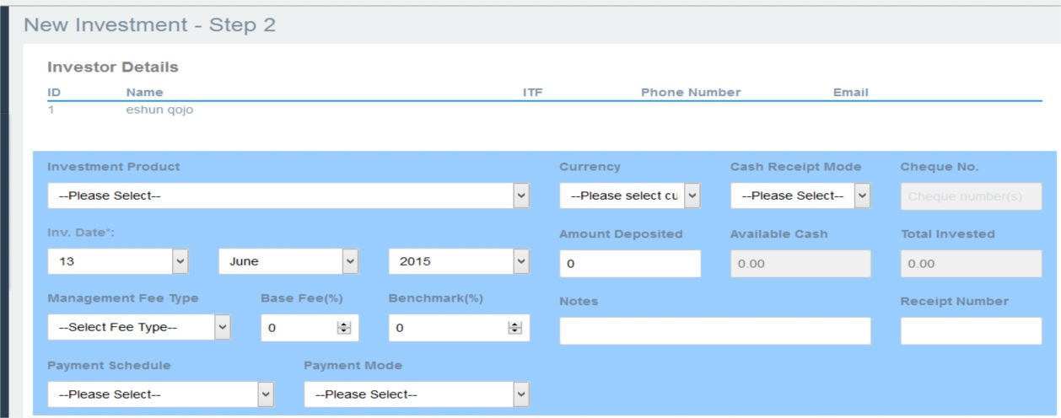

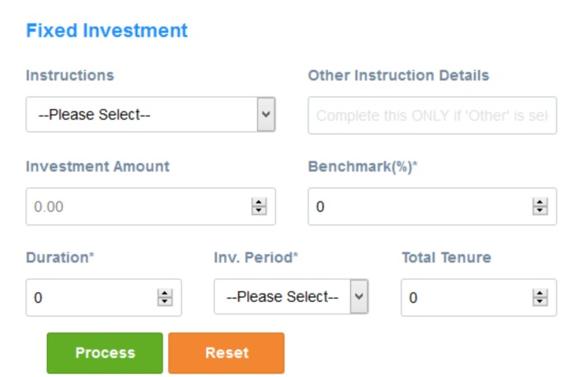 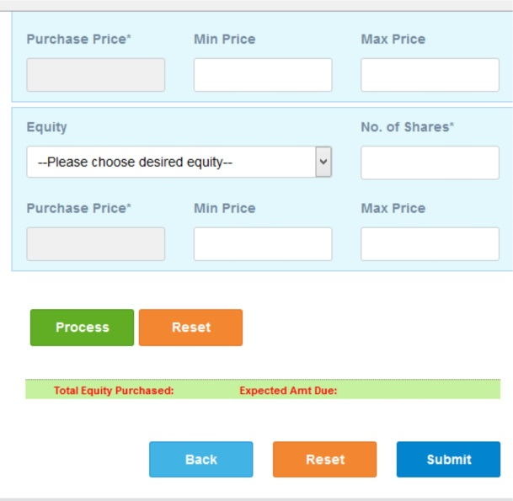

1. **Outbound Investments**

The outbound investments section is where the company’s own investments in other business and shares is recorded and monitored. It contains various sections:

1. Process Investments.
2. Manage Investments.
3. Daily Maturity List.
4. Monthly Maturity List.
5. Disposal Requests.
6. New/Edit Investment Destination.
7. Investment Destination Products.

The first step here is where you select the type of investment, whether fixed or equity investment. Then you proceed to fill in the boxes in the required type field. Eg. For fixed investment:

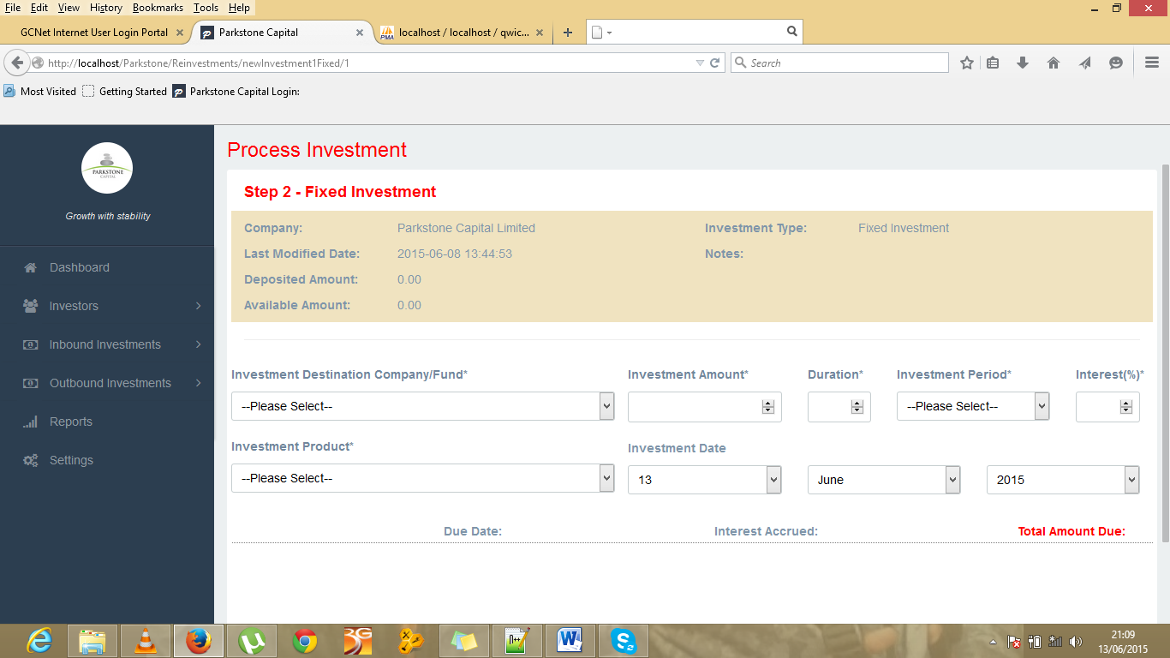

1. **Reports**

The reports page is simply made of the sum totals of all investments, bank account balances and financial statements.

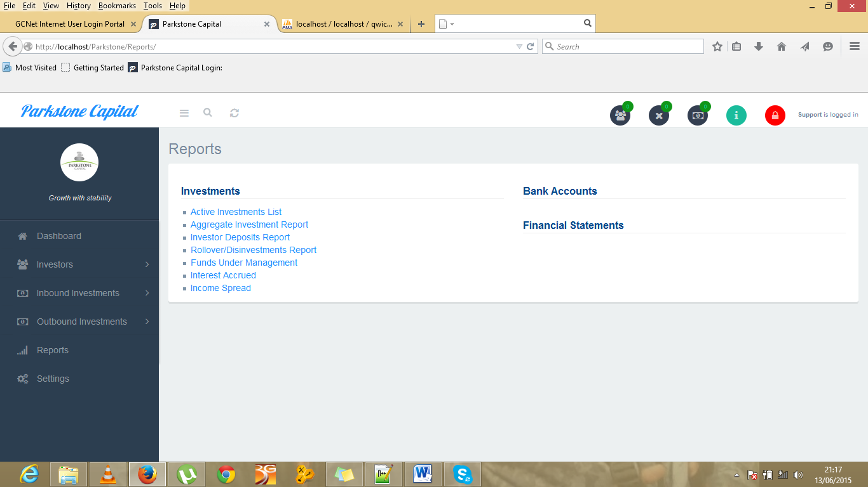

1. **Settings**

The settings page allows access to make changes to various aspects of the entire software to suit the company as well as the employee’s preferences.

